FAMILY TREE

AIM: To implement a prolog program to implement Family Tree.

OBJECTIVES:
- To develop a Prolog-based family tree system using facts and rules to determine relationships such as parent, child, sibling, grandparent, and grandchild.

ALGORITHM:
- Start the Prolog program.
- Define facts for male and female family members.
- Define parent relationships.
- Define rules for child, sibling, grandparent, and grandchild.
- Load the program into Prolog.
- Enter relationship queries.
- Display the corresponding family members.
- Stop.
SYSTEM-ARCHITECTURE:
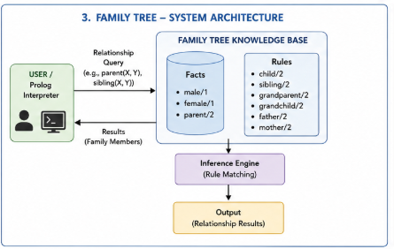

PROGRAM:
% FAMILY TREE

% Gender facts
male(john).
male(peter).
male(robert).
male(david).
male(michael).

female(mary).
female(susan).
female(linda).
female(karen).
female(emily).

% Parent facts
parent(john, peter).
parent(mary, peter).

parent(john, susan).
parent(mary, susan).

parent(peter, david).
parent(linda, david).

parent(peter, emily).
parent(linda, emily).

parent(robert, michael).
parent(karen, michael).

% Child relationship
child(X, Y) :-
parent(Y, X).

% Sibling relationship
sibling(X, Y) :-
parent(P, X),
parent(P, Y),
X \= Y.

% Grandparent relationship
grandparent(X, Y) :-
parent(X, Z),
parent(Z, Y).

% Grandchild relationship
grandchild(X, Y) :-
grandparent(Y, X).

% Father relationship
father(X, Y) :-
male(X),
parent(X, Y).

% Mother relationship
mother(X, Y) :-
female(X),
parent(X, Y).

OUTPUT:
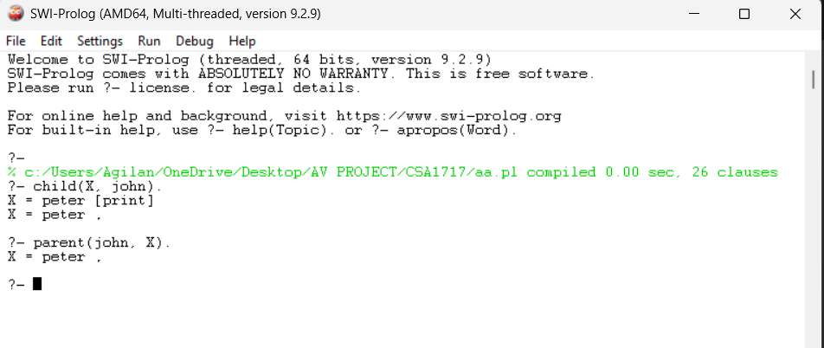

RESULT: Thus the Family Tree is implemented successfully using Prolog program.

